**Analysis of Algorithms (CSE212)**

**Module 2- BRUTE FORCE**

**Question Bank**

1. Explain Brute Force algorithm design technique with example.
2. Design selection sort algorithm to perform sorting and analyze its time efficiency.
3. Design sequential search algorithm to perform searching and analyze its time efficiency
4. Design Brute Force String Matching algorithm and analyze its best and worst case efficiencies.
5. Apply Brute Force String Matching algorithm and find the matching position of the pattern in the given text

TEXT : P**.**V**.**Sindhu_Won_Goldmedal_in_WBC

PATTERN: old

1. Discuss Strengths and Weaknesses of Brute Force technique
2. Apply Exhaustive Search procedure to find the shortest path for the given Travelling Salesperson Problem

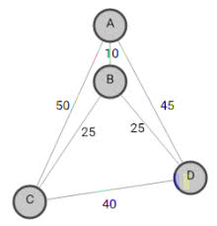

8. Find the solution to the given Knapsack problem using exhaustive search method.

Knapsack capacity W=5

item weight value

1. 2 12
2. 1 10
3. 3 20
4. 2 15

---------STUDENTS CAN EXPECT SUCH TYPE OF PROBLEMS WITH DIFFERENT VALUES------

**\*\*\*\*\* Happy Learning \*\*\*\*\***